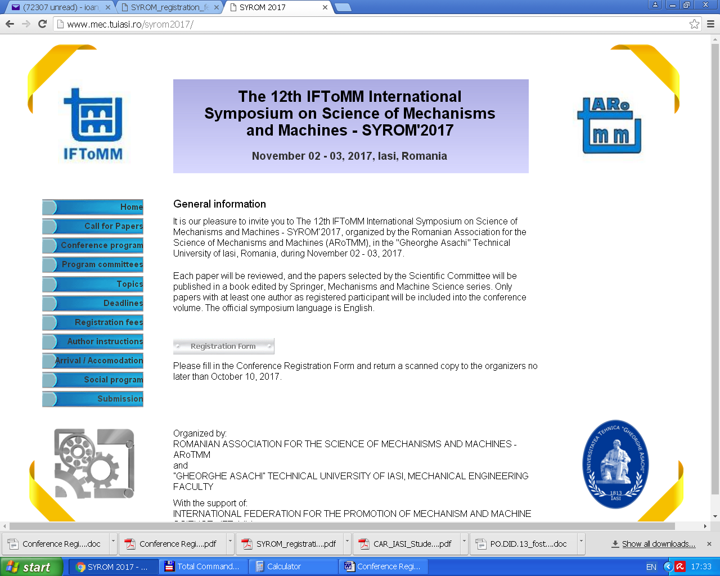

Please fill-in this form (2 pages), PRINT it, SIGN it, SCAN it and send the scanned copy by e-mail to idorofte@mail.tuiasi.ro; ioan_doroftei@yahoo.com, before October 10th, 2017. Should you have any questions, please do not hesitate to contact us.

Full Name

First Name

Last Name

Affiliation

Address

Street Address

City

Postal Code / Zip Code

Country

E-mail

Phone Number

Conference Information

Please select the type of registration you would like*

Full Conference Registration – 250 Eur (350 Eur for Non IFToMM Members); Doctoral Student / Student Full Conference Registration – 150 Eur

*At least one Conference Registration Fee has to be paid in order to have the paper(s) published ** A proof of active doctoral student / student should be presented
Extra Paper

Extra Paper (by same first author) - 100 Euro

Accompanying person

Accompanying person at Meals and Gala Dinner (no conference materials) - 100 Euro

Type of Presentation

Oral Presentation

Poster Presentation

NOT ATTENDING

Meals

All Full Conference Registration fees include the following meals: Coffee breaks, Lunch (Nov 02 and Nov 03) and Gala Dinner (Nov 02).

Dietary Needs

Vegetarian Meals

Non-Vegetarian Meals

Travel information

Arrival in Iasi (date, time, transportation)

Conference materials will not be provided without payment of the registration fee. No refund will be granted for no-show.
Privacy clause: The information you provided on this form will be used for the sole purpose of processing your enrolment for the SYROM 2017 Conference and printing of the conference directory. The information provided will not be made available for any other purpose.

Date

Signature

